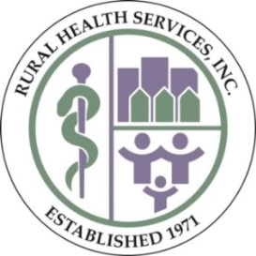
School-Based Healthcare Services
School-Based Healthcare staff strives to make our patients feel comfortable and at home. Our highly-trained staff offers a wide range of services. We are committed to providing children with the best care possible in a setting that is convenient, comfortable, and state-of-the-art.

Medical| Dental | Behavioral Health | Outreach

Find Us At Aiken County Schools:

A.L. Corbett Middle | Aiken Elementary | Aiken Intermediate | Belvedere Elementary | Byrd Elementary | Chukker Creek Elementary | Clearwater Elementary | Cyril B. Busbee Elementary | East Aiken Elementary | Gloverville Elementary |Graniteville Elementary | Greendale Elementary |Hammond Hill Elementary |J.D. Lever Elementary | Jefferson Elementary |Millbrook Elementary | Mossy Creek Elementary | New Ellenton Middle | North Aiken Elementary | North Augusta Elementary | Oakwood-Windsor Elementary | Redcliffe Elementary |Ridge Spring-Monetta Elementary | Ridge Spring-Monetta Middle | Warrenville Elementary

Location of Services
The school-based healthcare staff provides services to children in 25 schools in Aiken County. Services for children will be provided at school either on the Clyburn Community Health Express or in the school building. A parent must complete a registration and consent form to receive services at a school location.
Medical Care for Children
Services provided by the school-based medical staff will provide well child exams, medical screening, and treatment. Well child exams include screenings (urine and blood), head to toe examination, and behavioral health screening. If additional medical attention is needed, a member of the school- based medical staff will contact the parent to discuss next steps.

Dental Care for Children
Services provided by the school- based dental staff
include basic dental screenings, oral prophylaxis, fluoride applications, sealants, diagnostic screenings, fillings, and periodontal therapies. The staff will seek to provide pain-free dental services. If additional dental services are needed, a member of the school based dental staff will contact the parent to discuss next steps.

Behavioral Health Services
Services provided by behavioral health staff include screening to identify behaviors that hinder success in school, home, or community. Counseling and/or intervention as needed will be provided with parent consent.

Outreach

Our Outreach department assists individuals needing insurance through the Affordable Care Act (ACA). The Outreach staff can also assist with completing ACA enrollment paperwork. Please contact the

Director of Outreach at 803-380-7013

How Will My Child Enroll for Services?
Parent can stop by the front office at the school or visit any of the health center locations to pick up the enrollment form. The form is also on the school and Rural Health Services websites. Parent will need to complete the enrollment form and return to the school or health center locations as soon as possible.

How Will My Child Schedule an Appointment?
Once the enrollment form is completed, your child will be scheduled for an appointment by a school- based healthcare staff. The school- based healthcare staff will notify the school of your child’s appointment in advance.

How Will My Child Receive Services?
The front office staff at the school will call for your child to meet the school- based healthcare staff in the front office. A member of the school-based healthcare staff will then walk your child to the service provider and back to the front office of the school building when the appointment is completed.
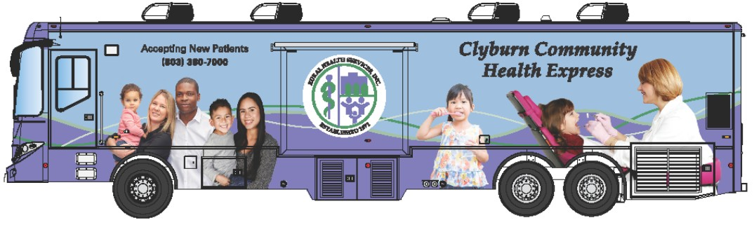

*If you are interested in having us at your school or community, please call the number below.

803-219-1926
Revised 8/23/2021

